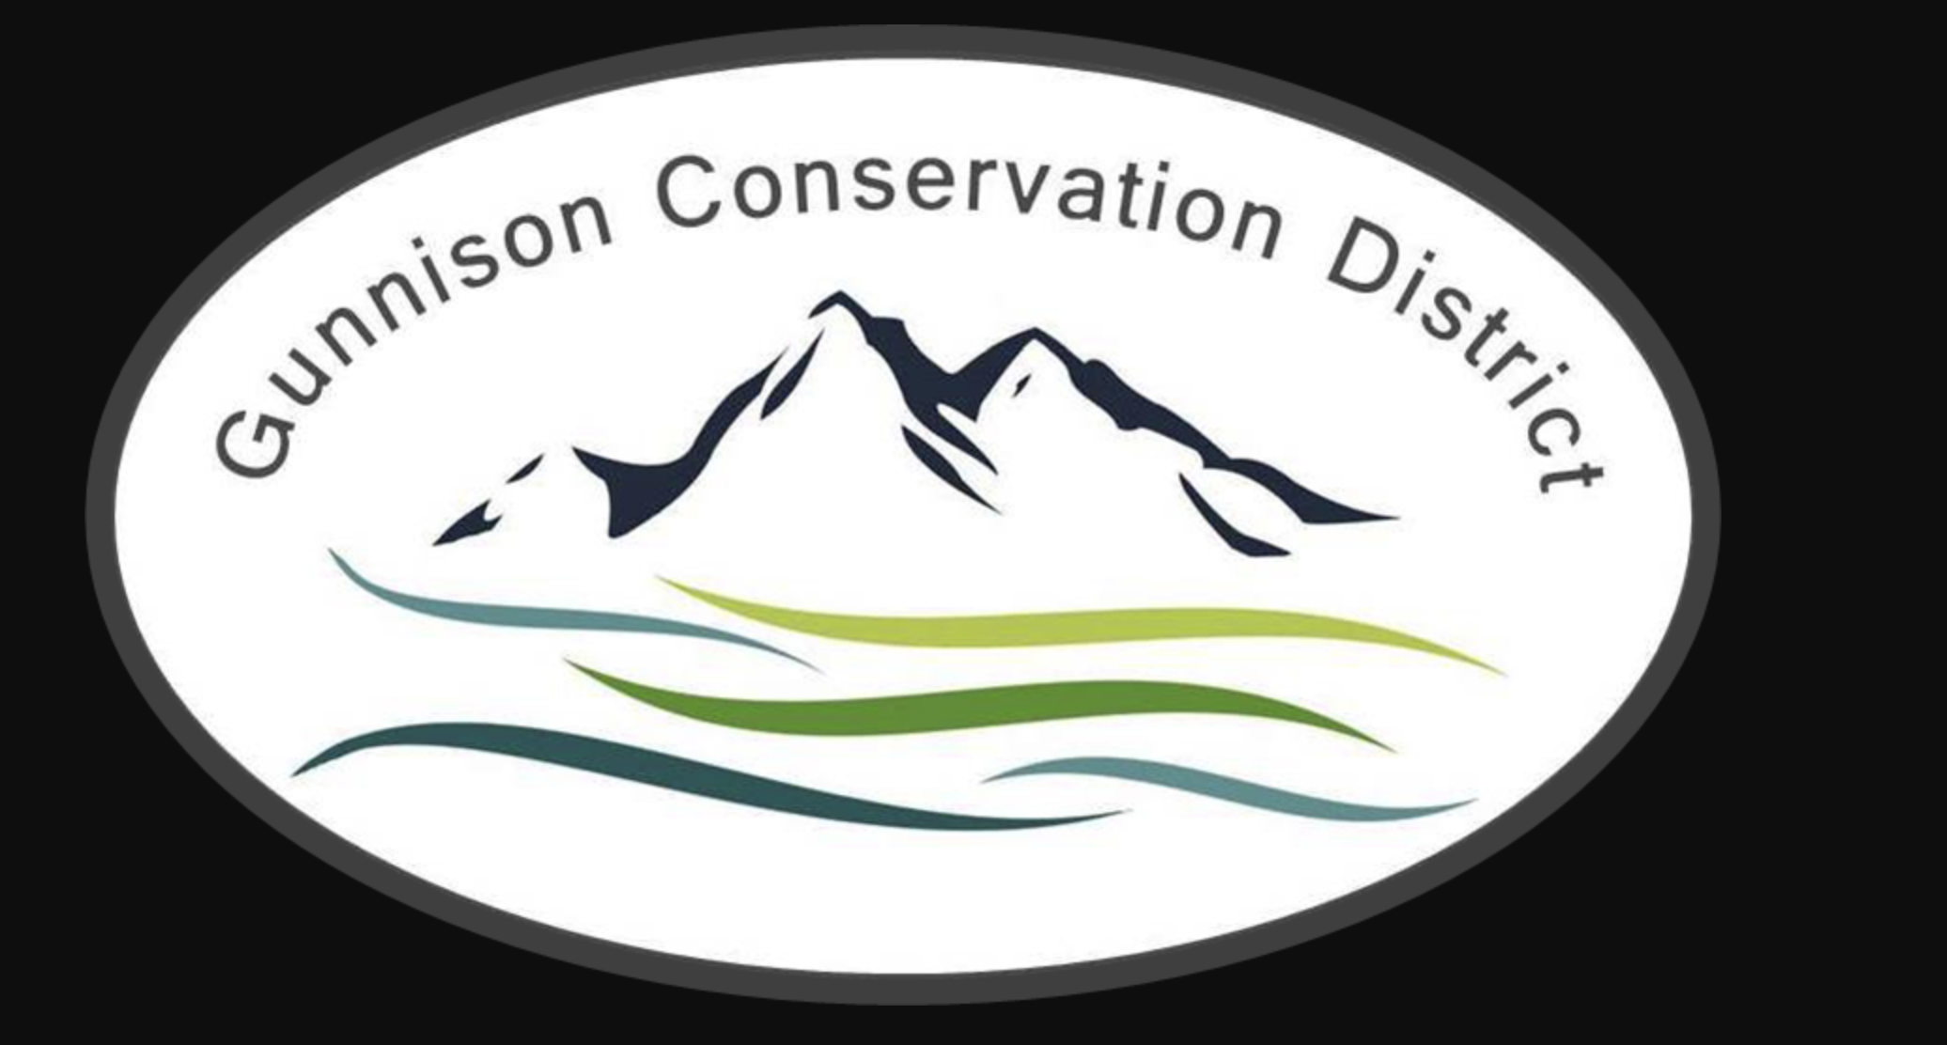

**Gunnison Conservation District**

216 N Colorado St

Gunnison, CO 81230

970–707-3047

**AGENDA – Regular Meeting**

**Date:** **December 17, 1:30 PM**

Meeting held at Forest Service Office, 216 N. Colorado St. Gunnison CO 81230

**Call to Order**  **Bill Ketterhagen** 1:30 PM

**Partner Updates**

N.R.C.S Dan Olson/Jamison Jeweks

Colorado State Forest Service Mike Tarantino/ Dylan Eimer

CSU Extension Hannah Kersting

Bird Conservancy of the Rockies Marcella Tarantino

U.G.R.W.C.D Beverly Richards

Trout Unlimited Jesse Krupthaupt

Crested Butte Land Trust Jon Mugglestone

**Approval of Minutes** **Board**

**Treasurer’s Report** **Jon Mugglestone, Bill Ketterhagen**

**Financial Statements** **Provided by Tonya Carr**

**Old Business**

**DCT Project Updates Ben Prior**

CDA/USFS grant final report.

Gunnison County Contract Renewal for 2025.

**DM Update Tonya Carr**

BOR B2E Grant proposal submitted.

Submitted last NFWF reimbursement, not including holdback.

Adoption of 2025 General Fund Budget

**New Business**

**DCT Update** **Ben Prior**

New NRCS practices for predator conflict mitigation.

Habitat Prioritization Tool update.

**DM Update** **Tonya Carr**

DCT Reimbursement, file General Fund Budget with Dola, end-of-year taxes, election filings and publications. Insurance renewals.

Annual Report

**Upcoming Events**

GCD Annual Meeting

**Next Meetings**

GCD Board Meeting: January 21, 1:30 PM

GCD Board Meeting: February 18, 1:30 PM

GCD Board Meeting: March 18, 1:30 PM

Adjourn Bill Ketterhagen