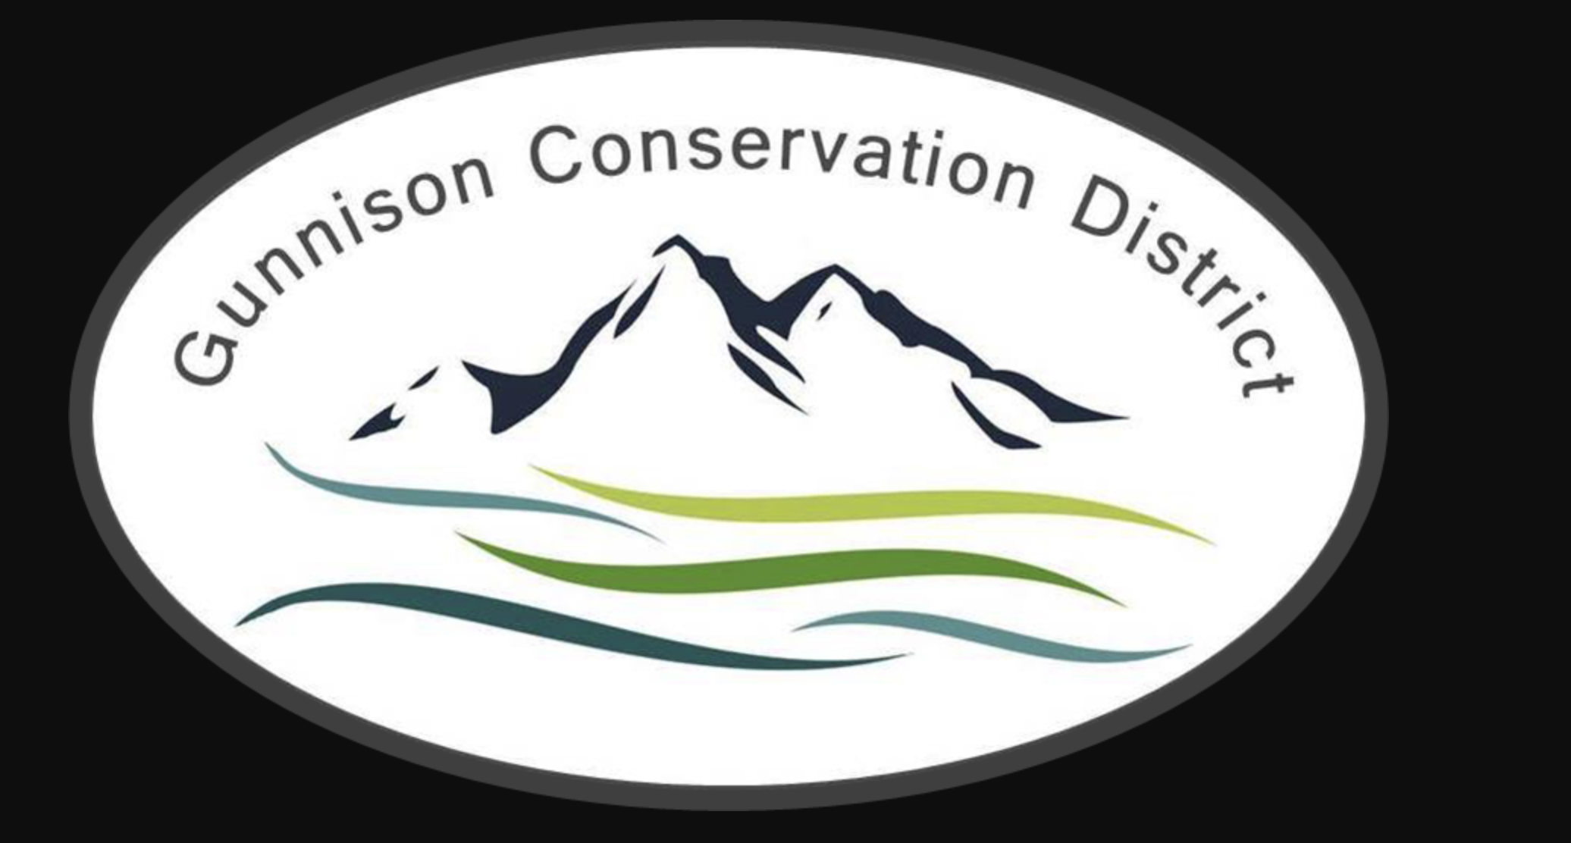

**Gunnison Conservation District**

216 N Colorado St

Gunnison, CO 81230

970–707-3047

**AGENDA – Regular Meeting**

**Date: May 14th 6 PM**

Meeting held at Forest Service Office, 216 N. Colorado St. Gunnison CO 81230

**Call to Order** **Bill Ketterhagen** 6:00 PM

**Partner Updates**

N.R.C.S Dan Olson/Jamison Jeweks

Colorado State Forest Service Dylan Eimer

CSU Extension Hannah Kersting

Bird Conservancy of the Rockies Marcella Tarantino

U.G.R.W.C.D Beverly Richards

Trout Unlimited Jesse Krupthaut

**Approval of Minutes** **Board**

**Treasurer’s Report** **Rufus Wilderson/Tonya Carr**

Financial Statements

**Old Business**

**DCT Project Updates Aleshia Rummel**

RCPP: Ongoing discussion regarding potential opportunities.

**DM Updates Tonya Carr**

Streamline accessibility.

C.A West Bookkeeping in process of correcting past QuickBooks tax errors.

**New Business**

**DCT Update Aleshia Rummel**

**DM Update Tonya Carr**

Bridge funding.

The Quarry LLC notice of filing. Requires written receipt of notice from Conservation board.

CDA, State Auditor office delay processing audit exemption report.

Update on seed sales.

CDA annual dues.

**Next Meeting**

**Executive Session Immediately following regular meeting May 14, 2024**

GCD Board Meeting: June 18th 6:00pm

GCD Board Meeting: July 16th 6:00pm

GCD Board Meeting: August 20th 6:00pm

Adjourn Bill Ketterhagen

**Upcoming Events**

**Conference Call In #: 1-612-746-7368 Conference Code: 694688**